**Five Guys Vue lab**  
  
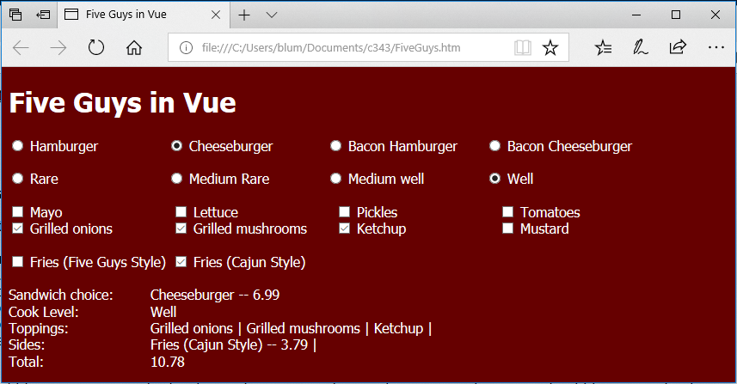  
  
Have Vue read the file [FiveGuys.json](http://www1.lasalle.edu/~blum/c343wks/FiveGuys.json) and generate two sets of radio buttons (for sandwich and cook level) and two sets of checkboxes (for toppings and sides). Take the user's order and display his/her choices. Determine the price -- sandwich plus any sides (toppings are free).  
  
My file reading looked like:

fetch('FiveGuys.json')

.then(response => response.json())

.then(data => {

this.sandwiches = data.sandwich;

this.cook_levels = data.cook_level;

this.toppings = data.toppings;

this.sides = data.sides;

})

.catch(function(error){

console.log(error);

})

I gave the sandwiches and sides a change event v-on:change="calc" (like the click event in the Roman Numeral guessing game) and the handler looked like

methods: {

calc(){

//alert("HI");

this.total=0.0;

if(this.user_sandwich){

this.total = this.user_sandwich.sandwich_price;

}

for(i=0; i< this.user_sides.length; i++){

this.total += this.user_sides[i].side_price;

}

this.total = parseFloat(this.total).toFixed(2);

}

}